本文件中所有SQL代碼 和 textbook中SQL重要的東西被抄在了”SQL-quick-pickup”中, 看那個文件即可. “SQL-quick-pickup”中也有解釋, 所以看“SQL-quick-pickup”時不需要看本文件和textbook. 但若看一些比如SQL的歷史甚麼的以及更深入的東西, 還是要看本文件和textbook, 尤其是textbook.


The above figure (only two words SQL Queries): Most databases support some form of SQL. Most data sit in relational databses and I access through SQL.

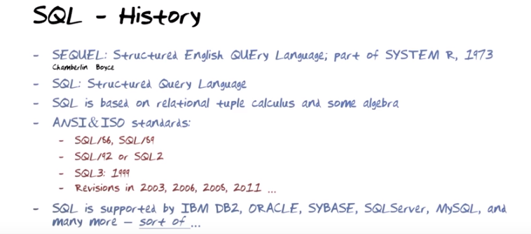

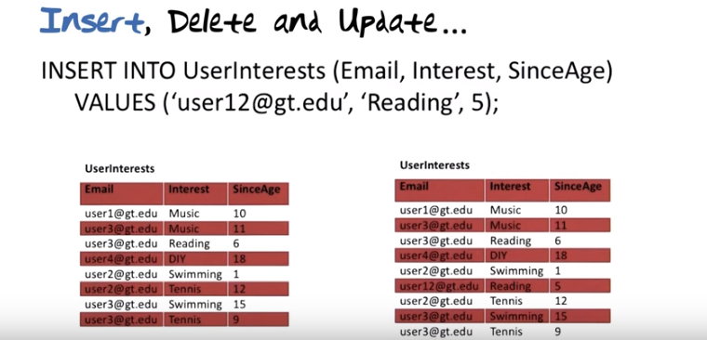
上圖: 一般說來, INSERT一次只加入一行, 除非是從database本身中提取一些東西加入.

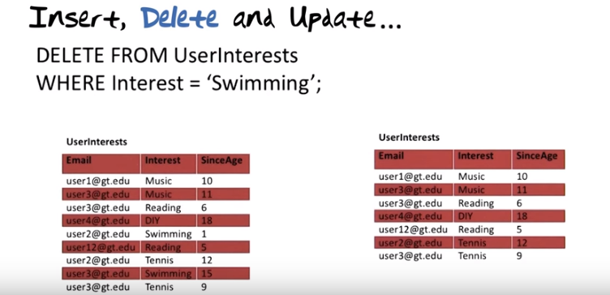
上圖: DELETE一次可以刪除多行.

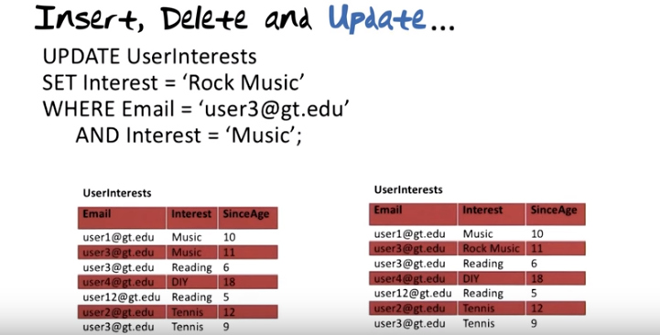
上圖: UPDATE一次也可以處理多行.

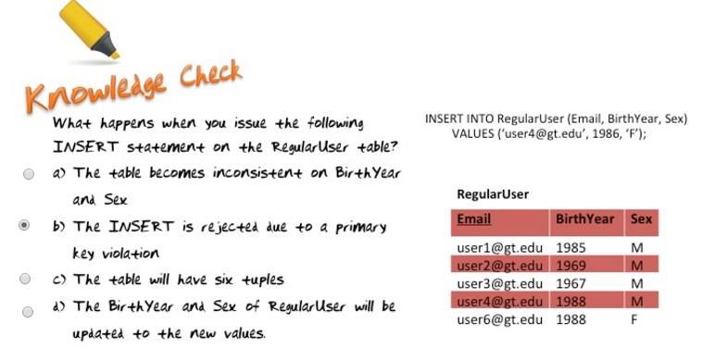
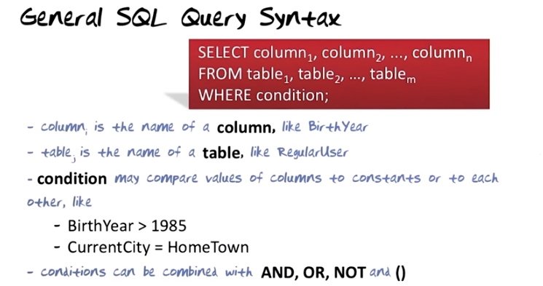
上圖中的Query應該是只指SELECT. In Commercial relational database, we often use the terms column instead of attribute, table instead of relation, and row instead of tuple.

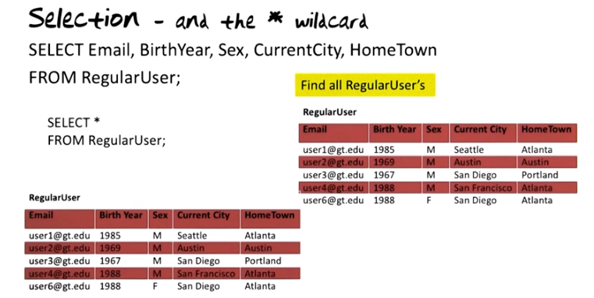
上圖: 注意SQL語句要以分號結尾. SELECT *那句是跟上面SELECT Email...等價的.

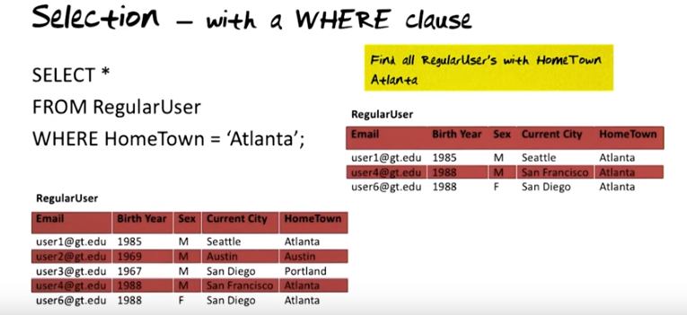

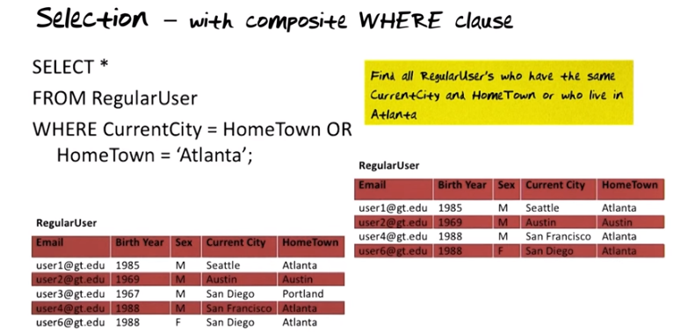

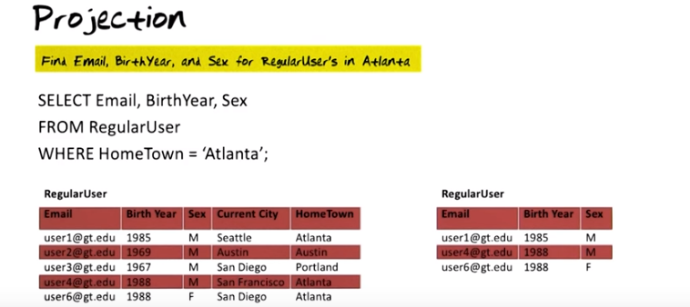

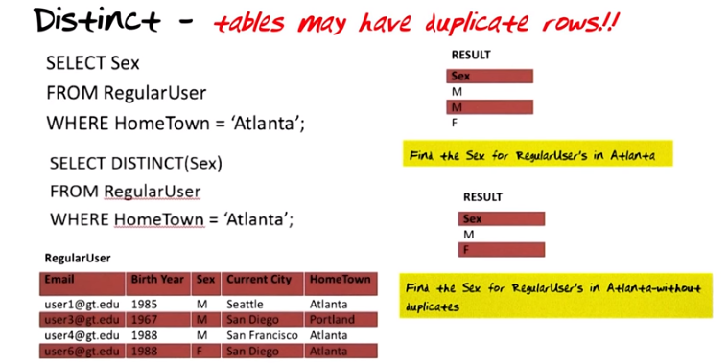
The above figure: In SQL, tables may have duplicate rows.

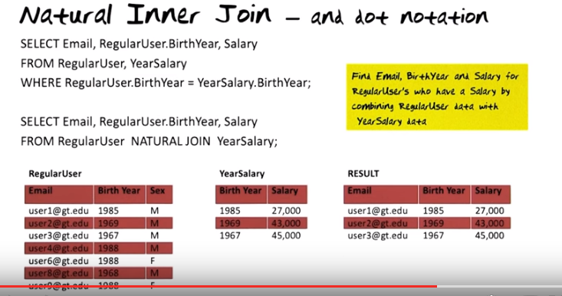
The above figure: when no ambiguity is present like with Email and Salary, we don't have to use dot notation, we can but we don't have to. For Birth Year, it could be the birth year form RegularUser table of from the YearSalary table. So we have to tell the database system which table it's from.

We must include Birth Year (ie, in the result table) and we must say which table it is pulled from.

In the relational algebra, we didn't have to specify the join condition when the attribute or column names are the same. In SQL you have to.

有NATURAL JOIN的那段跟它上面的SELECT Email...等價.

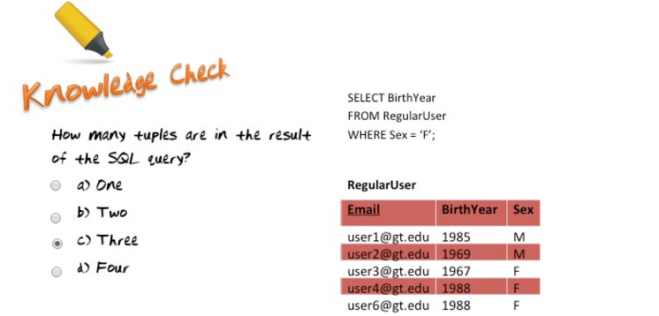

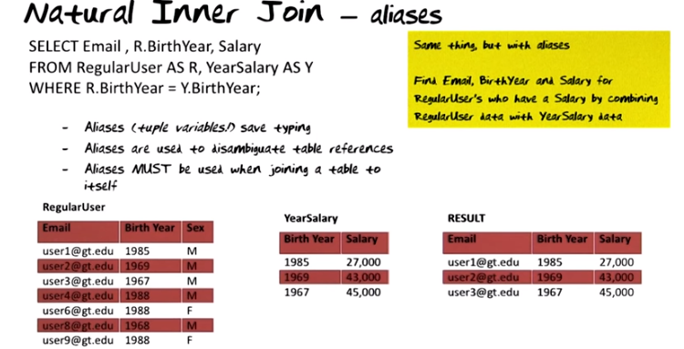

The above figure: I strongly recommend using aliases when you write queries.

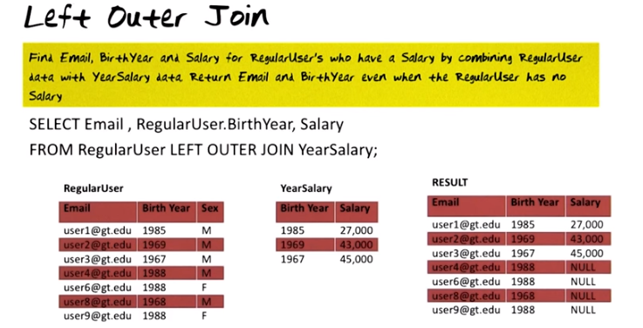

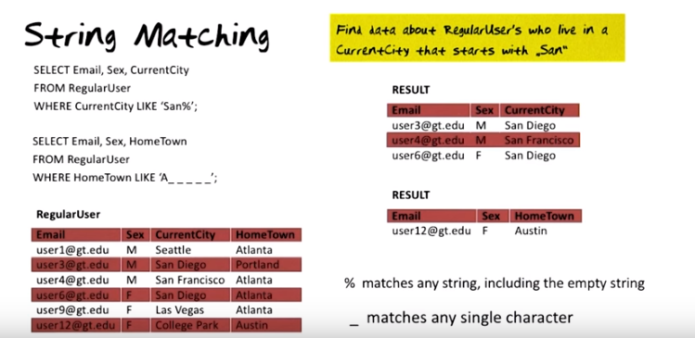

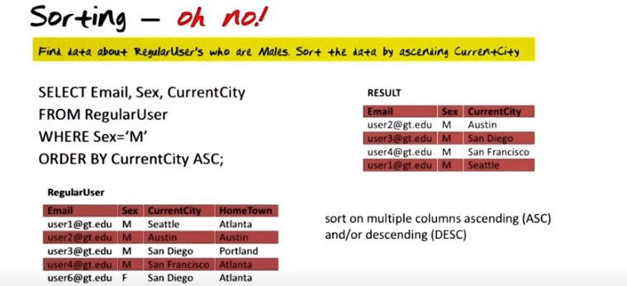

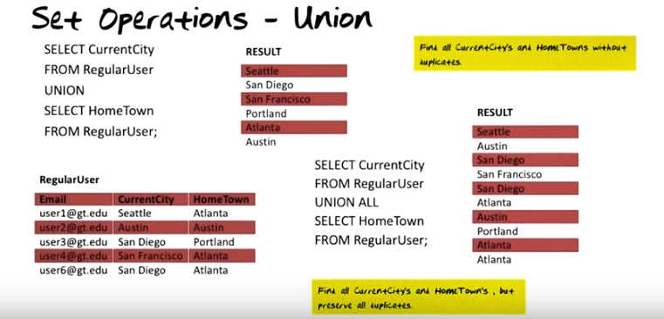

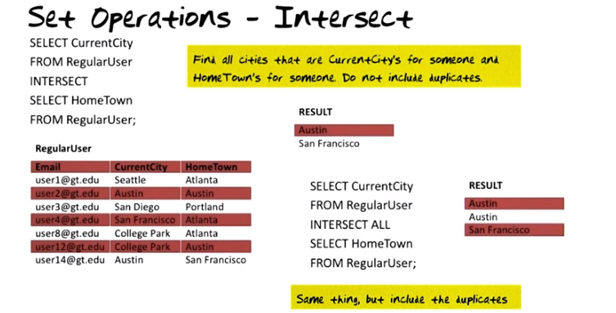
The above figure: INTERSECT ALL情況時, Austin is counted twice. Why is that? Well, as you see here, Austin is the current city for two people, and Austin is also the hometown for two people.

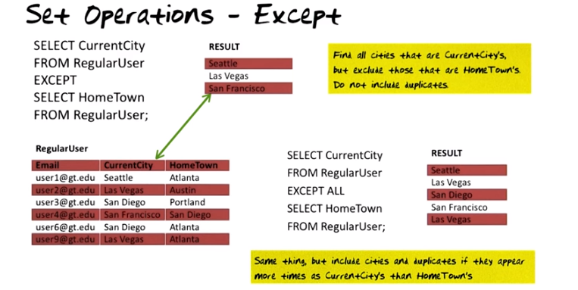

The above figure: EXCEPT ALL情況時, Las Vegas在RESULT中出現了兩次, 是因為 CurrentCity中有兩個Las Vegas, Hometown中沒有Las Vegas. San Diego出現在了RESULT中, 是因為RegularUser中, CurrentCity中有兩個San Diego, Hometown中有一個San Diego. Hometown中的San Diego抵消掉了 CurrentCity中的一個San Diego, CurrentCity中還剩下一個San Diego, 所以出現在了RESULT中. 2016.12: 最好的方法就是求EXCEPT前, 對EXCEPT兩邊的先去重復. 求EXCEPT ALL時, 將EXCEPT ALL兩邊的SanDiego都看成不同的(即兩個不同的城市偶然都叫SanDiego而已).

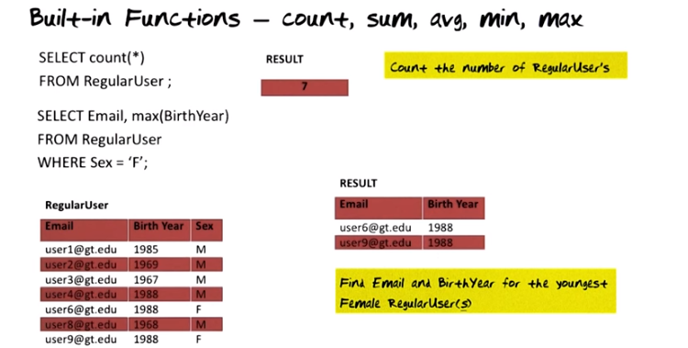

The above figure: count時, the result here is a table with a single column and a single row and the number 7 in it.

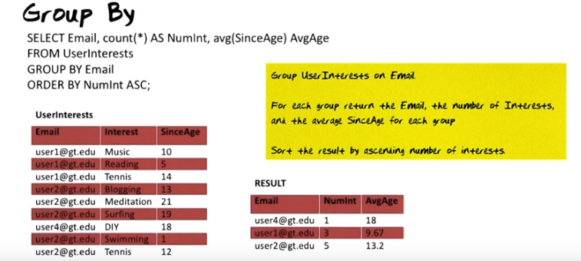
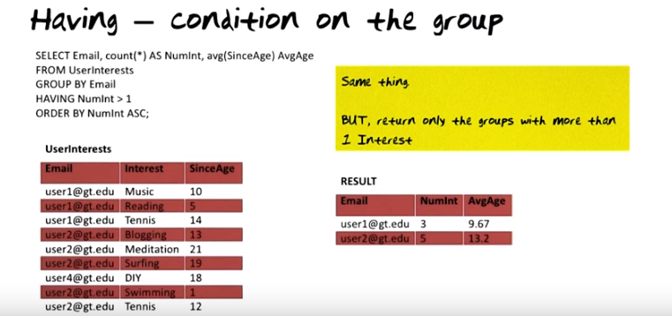

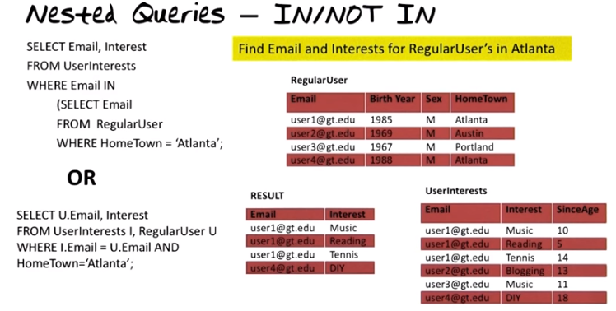
上圖先看inner query, 再看outer query

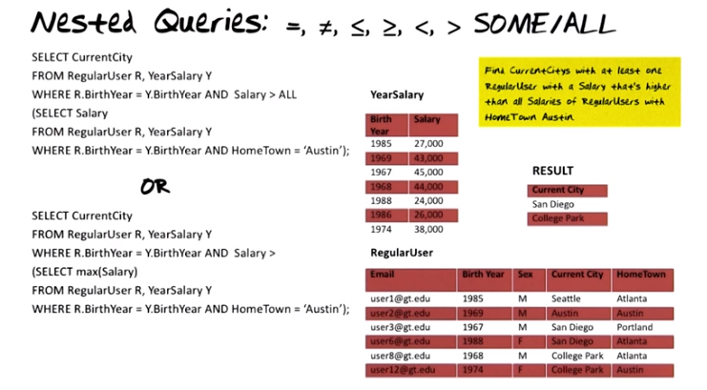
上圖中Hometown是Austin的人(user2和user12)的收入是43,000和38,000. 要找的是收入比這兩個都高的. 題目中的Find CurrentCitys with at least one RegularUser...的意思是, 例如San Diego有兩個人(user3和user6), 他們的收入分別為45,000和24,000, 有一個人的數入(45,000)比43,000和38,000都大, 所以San Diego要在RESULT中. College Park同理也在RESULT中. 代碼中的ALL應該是和它下面的{}連在一起的, 即一個ALL{...}語句.

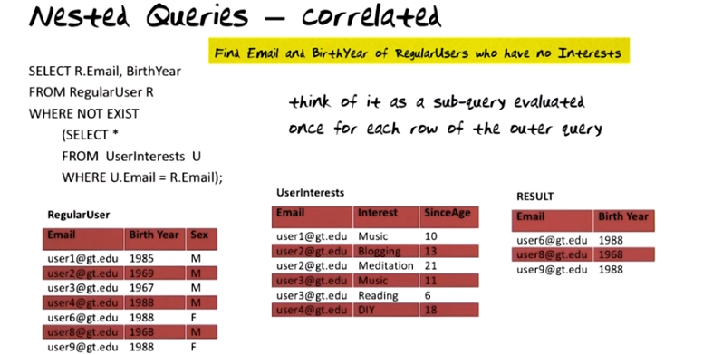
(2016.12表示從內往外看也沒問題)
上圖代碼中inner query用到R, 但R是在outer query中定義的, 所以的R是一個reference out of scope, 這是correlated的. 對於這種代碼, 不能從裡往外看, 而是要think of it as a sub-query evaluated once for each row of the outer query. 即在表中一行一行地取, 代入代碼中由外向裡看. 比如RegularUser第一行user1, 代入代碼外層中, R就是user1, 然後看內層, UserInterest中能夠找出user1@gt.edu, 所以WHERE NOT EXIST{...}是false的, 所以user1沒在RESULT中. 同理, user6在RESULT中.

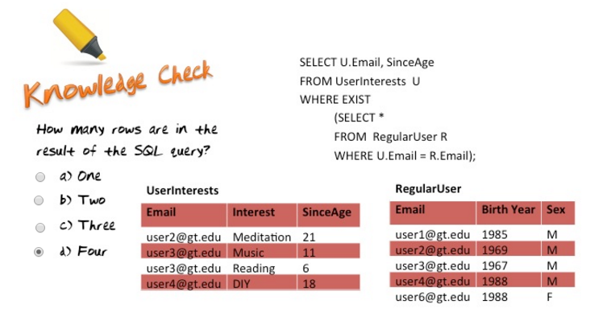
上題中的四個即user2, user3, user3, user4, 注意可以有duplicate.

